JSON-data on website to fetch in this example app - June 14, 2016

This is cut/paste from website that contains JSON data to fetch.   
website: <http://codeentries.com/api/users.json>

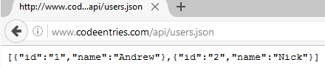  
  
==========================================================================

**Here is Android App screen output !!**  
   
